**CS 308 Computer Graphics Programming**

**Individual Project Proposal**

Department of Statistics and Computer Science

Faculty of Science

University of Peradeniya

|  |  |
| --- | --- |
| Name | R. D. Viharagedara |
| Registration No | S/16/494 |
| Date | 2021/1/11 |
| Degree | BSc Honours in Computer Science |

1. **Project title:**

3D Model of St. Sylvester’s College Building

1. **Brief overview of project:**

This building is build based on the architecture of the catholic church. It consists of two floors and a courtyard. The following figures will give the basic idea of the building and the courtyard.

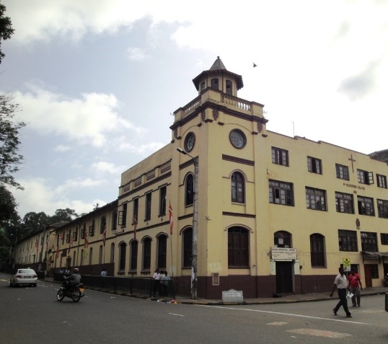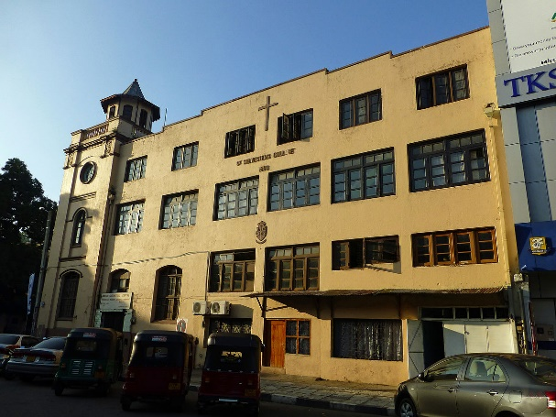

**Figure 1:** Front view of the building. **Figure 2:** Side view of the building.

**Figure 3:** The courtyard and the two floors.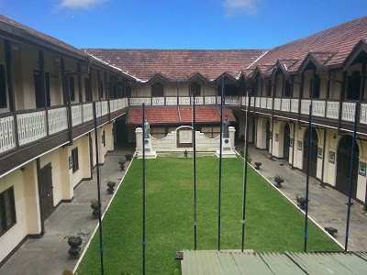

1. **Project details:**

**The objectives of the project:**

* Build the 3D model of the building
* Build the 3D model of the courtyard
* Build the 3D model of the pond in the courtyard
* Animate doors and windows opening and closing
* Animate the shadows of the building according to the sunlight

**Project Significance:**

* Visualize the detailed 3D model of St. Sylvester’s College building

**Project Scope:**

* The building and the courtyard will be modelled with their original details as possible.
* The animation of doors and windows opening and closing will be keyboard functions.
* Camera will be able to freely moved around.

**Limitations:**

* Some of the complex details of the building will not be modelled
* There are two statues in the courtyard, they will not be modelled
* The water movement in the pond will not be modelled